Granger predictability: GBPUSD and USDCAD
Method 13 / daily log returns / p=1 and p=5 / Alpari D1 full available history

Study setup
Logical pair: GBPUSD , USDCAD
Broker symbols: GBPUSD_i , USDCAD_i
Snapshot: 2026-11-03_majors_alpari_D1
Timeframe: D1
Matched return window: 1999-01-05 to 2026-11-02 (UTC bar dates)
Matched return count n: 7205
Dropped unfinished last bar dated 2026-11-03 UTC after a tick-volume check against the prior complete day.
Lag orders pre-specified: p=1 and p=5; both directions
Headline: p=5 joint F test in both directions
Complete matched rows (Excel): GBPUSD-USDCAD_Granger_D1.xlsx
Complete matched rows (HTML table): GBPUSD-USDCAD_Granger_D1_data.html

Method carried forward
Granger predictability asks whether lagged X helps explain Y beyond lags of Y alone on matched daily log returns of close, ln(close_t / close_t-1). Quotes are not inverted. For lag order p, the unrestricted model is y_t on an intercept, y_{t-1}..y_{t-p}, and x_{t-1}..x_{t-p}. The restricted model drops the x lags. The test is an F comparison of residual sums of squares via OLS (numpy.linalg.lstsq) and scipy.stats.f. Orders p=1 and p=5 are pre-specified; both directions are tested. The headline is the p=5 joint test in both directions. p=1 is reported beside it because the guide formula is the one-lag regression. Rejecting H0 is statistical predictability in mean in this sample; it is not economic causation and not a trading signal. There are 56 directed tests at p=5 across the 28 pairs.

Results
direction | p_lags | n | f_stat | p_value | b | df1 | df2
GBPUSD_to_USDCAD | 1 | 7204 | 1.5115478 | 0.21894322 | 0.01483756 | 1 | 7201
GBPUSD_to_USDCAD | 5 | 7200 | 0.74362727 | 0.59069491 | nan | 5 | 7189
USDCAD_to_GBPUSD | 1 | 7204 | 10.219121 | 0.00139593 | -0.04638104 | 1 | 7201
USDCAD_to_GBPUSD | 5 | 7200 | 3.6239697 | 0.00282266 | nan | 5 | 7189

Conclusion
Headline p=5 joint tests for GBPUSD and USDCAD: GBPUSD->USDCAD F=0.7436 (p=0.590695); USDCAD->GBPUSD F=3.6240 (p=0.00282266); usable rows n=7200. One-lag slopes: b_GBPUSD->USDCAD=0.0148 (F=1.5115, p=0.218943); b_USDCAD->GBPUSD=-0.0464 (F=10.2191, p=0.00139593). Rejecting H0 is in-sample mean predictability, not economic cause and not a trading signal.

Charts
Daily closes

Daily log returns

Granger F statistics
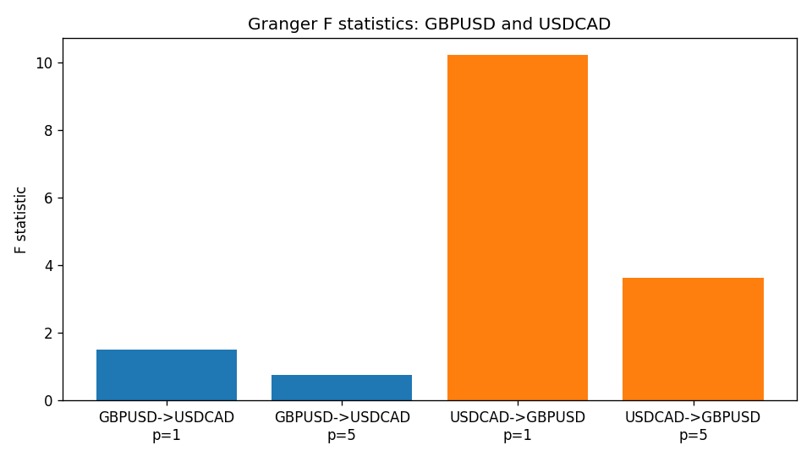

Data report
Every matched row is stored in the sibling Excel workbook named GBPUSD-USDCAD_Granger_D1.xlsx (sheet matched_rows). The results sheet holds the four F tests. Embedding all rows as a Word table is impractical; the Word file holds column summaries and the first and last 15 rows.
Columns: time, GBPUSD_open, USDCAD_open, GBPUSD_high, USDCAD_high, GBPUSD_low, USDCAD_low, GBPUSD_close, USDCAD_close, GBPUSD_tick_volume, USDCAD_tick_volume, GBPUSD_spread, USDCAD_spread, GBPUSD_real_volume, USDCAD_real_volume, GBPUSD_log_return, USDCAD_log_return
Column summaries (matched calculation rows)
column | count | mean | std | min | 25% | 50% | 75% | max
GBPUSD_open | 7205 | 1.5161639 | 0.2182756 | 1.06854 | 1.32505 | 1.51142 | 1.63205 | 2.1066
USDCAD_open | 7205 | 1.2670469 | 0.16900802 | 0.9168 | 1.119 | 1.29857 | 1.3723 | 1.6183
GBPUSD_high | 7205 | 1.5224596 | 0.21884187 | 1.08366 | 1.32981 | 1.5182 | 1.6384 | 2.1161
USDCAD_high | 7205 | 1.2719479 | 0.16896591 | 0.9336 | 1.1234 | 1.30394 | 1.3769 | 1.619
GBPUSD_low | 7205 | 1.5098441 | 0.21750249 | 1.03518 | 1.31956 | 1.50336 | 1.62444 | 2.0983
USDCAD_low | 7205 | 1.2624879 | 0.16904619 | 0.9056 | 1.1144 | 1.29361 | 1.36793 | 1.6102
GBPUSD_close | 7205 | 1.5162333 | 0.21823062 | 1.06879 | 1.3252 | 1.5114 | 1.6322 | 2.1065
USDCAD_close | 7205 | 1.2670655 | 0.16898286 | 0.916 | 1.11851 | 1.29871 | 1.37253 | 1.6137
GBPUSD_tick_volume | 7205 | 94776.836 | 153518.92 | 62 | 9986 | 52867 | 91739 | 1273370
USDCAD_tick_volume | 7205 | 80835.261 | 147176.39 | 37 | 5509 | 40849 | 71515 | 1410818
GBPUSD_spread | 7205 | 26.978348 | 19.192834 | 0 | 11 | 20 | 50 | 50
USDCAD_spread | 7205 | 23.508952 | 18.282466 | 0 | 9 | 17 | 40 | 60
GBPUSD_real_volume | 7205 | 3.5541156e+09 | 8.441481e+10 | 0 | 0 | 0 | 0 | 2.4038164e+12
USDCAD_real_volume | 7205 | 1.8330194e+10 | 9.6578305e+10 | 0 | 0 | 0 | 0 | 2.5751613e+12
GBPUSD_log_return | 7205 | -2.188e-05 | 0.00563988 | -0.08388241 | -0.00312535 | 3.221e-05 | 0.0031749 | 0.03112653
USDCAD_log_return | 7205 | -1.219e-05 | 0.00514402 | -0.03859748 | -0.00283601 | 4.92e-05 | 0.00272763 | 0.03436319
First 15 matched rows (selected columns)
time | GBPUSD_close | USDCAD_close | GBPUSD_log_return | USDCAD_log_return
1999-01-05 | 1.6547 | 1.5123 | -0.0028966287 | -0.010131666
1999-01-06 | 1.6537 | 1.5118 | -0.00060452184 | -0.0003306769
1999-01-07 | 1.6502 | 1.5141 | -0.002118709 | 0.0015202092
1999-01-08 | 1.6405 | 1.511 | -0.0058954193 | -0.0020495197
1999-01-11 | 1.6312 | 1.5057 | -0.0056851331 | -0.0035137769
1999-01-12 | 1.6349 | 1.5157 | 0.0022657001 | 0.0066194721
1999-01-13 | 1.6499 | 1.5226 | 0.0091330396 | 0.0045420214
1999-01-14 | 1.6531 | 1.5332 | 0.0019376331 | 0.0069376546
1999-01-15 | 1.6502 | 1.5245 | -0.0017558204 | -0.0056905671
1999-01-18 | 1.6522 | 1.526 | 0.0012112405 | 0.00098344542
1999-01-19 | 1.6553 | 1.5302 | 0.0018745281 | 0.002748513
1999-01-20 | 1.6472 | 1.5211 | -0.0049053846 | -0.0059646885
1999-01-21 | 1.6524 | 1.5146 | 0.0031518998 | -0.0042823796
1999-01-22 | 1.6565 | 1.5184 | 0.0024781662 | 0.0025057712
1999-01-25 | 1.6585 | 1.5197 | 0.0012066366 | 0.00085579808
Last 15 matched rows (selected columns)
time | GBPUSD_close | USDCAD_close | GBPUSD_log_return | USDCAD_log_return
2026-10-13 | 1.32534 | 1.4214 | 0.0036434319 | -0.0046395653
2026-10-14 | 1.31884 | 1.42356 | -0.0049164679 | 0.0015184751
2026-10-15 | 1.32757 | 1.41843 | 0.0065976411 | -0.0036101503
2026-10-16 | 1.33257 | 1.41357 | 0.0037592051 | -0.0034322068
2026-10-19 | 1.33024 | 1.41091 | -0.0017500314 | -0.0018835331
2026-10-20 | 1.3377 | 1.40569 | 0.0055923442 | -0.0037066008
2026-10-21 | 1.33937 | 1.4045 | 0.0012476328 | -0.00084691787
2026-10-22 | 1.33967 | 1.40081 | 0.00022396082 | -0.0026307268
2026-10-23 | 1.33684 | 1.40085 | -0.0021146949 | 2.85545e-05
2026-10-26 | 1.33359 | 1.40093 | -0.0024340661 | 5.7106554e-05
2026-10-27 | 1.33044 | 1.40449 | -0.0023648393 | 0.0025379458
2026-10-28 | 1.33254 | 1.39911 | 0.0015771808 | -0.0038379274
2026-10-29 | 1.33733 | 1.39895 | 0.0035881935 | -0.00011436495
2026-10-30 | 1.33913 | 1.39751 | 0.0013450605 | -0.0010298736
2026-11-02 | 1.3406 | 1.39837 | 0.0010971256 | 0.00061519094

